Bill Payment System
Software Requirements Document
V 1.0


 | Prepared By | Reviewed by | Approved By
Name | Sharika V
Role | Team member | Project Leader/ Team Leader/ Team Member | Project Manager/ Team Leader
Signature | VS
Date | 11/11/2014

Table of Contents
1.0 Introduction 3
1.1 About this document 3
1.1.1 Purpose & Scope of the document 3
1.1.2 Intended Audience 3
1.2 About the Software System 3
1.2.1 Purpose 3
1.2.2 Scope of the system 4
1.2.3 Exclusions 5
1.2.4 System Perspective 5
1.2.5 System diagram 6
1.2.6 Architecture diagram 6
1.2.7 System Environment 8
1.2.8 User Characteristics 8
1.2.9 Impact of the System 9
1.2.10 Assumptions, Dependencies, Risks / Constraints 9
1.2.11 Design Constraints 9
2.0 System Requirements 10
2.1 Functional Requirements 10
2.1.1 Home Module 10
2.1.2 Admin 10
2.1.2.1 Register Vendor Page 10
2.1.2.2 Vendor Updation Page 14
Vendor Selection Screen: 14
Vendor Updation Screen: 14
2.1.2.3 Register Customer Page 16
2.1.2.4 Customer Updation Page 18
2.1.2.5 Bill payment Page 20
2.2 Nonfunctional Requirements 21
2.2.2 UI Requirements: Inn 21
2.2.3 Performance Requirements: Pnn 22
2.2.4 Installation, Deployment & Operational Requirements: Onn 22
2.2.5 Maintainability & Portability Requirements: MPnn 22
2.2.6 Security Requirements Snn: 22
3. Requirements / Use Case Summary Table 22
4. Make /Buy analysis 24
4.1 Reusable components 24
5. Annexure 24
6. Change Log 24

Introduction

About this document

Purpose & Scope of the document
The purpose of the software requirements document is to systematically capture requirements for the project and the system “Bill Payment System” to be developed. Both functional and non-functional requirements of this system are captured in this document. It also serves as the input for the project scoping.
The scope of this document is limited to addressing the requirements from a user, quality, and non-functional perspective. It is recommended that design aspects are not added in this document

Intended Audience
Project Team

About the Software System
The following section will cover aspects related to
The client would like to develop an independent application Bill Payment System (BPS) to automate & manage bill payment mechanism in order to monitor and process various billing procedures between the vendors and customers.

Purpose
BPS is a system used for managing various activities such as vendor registration, customer registration, Bill payment etc. in order to facilitate various billing procedures between the vendors and customers.
The following are the modules in this proposed system
a) Vendor Registration
b) Vendor Updation
c) Customer Registration
d) Customer Updation
e) Bill payment/Pending

Scope of the system
The scope of the system is explained through its modules as follows
- Vendor Registration module – This module is used for registering the details of a vendor into the system
- Vendor Updation - This module is used for updating the vendor details into the system.
- Customer Registration - This module is used for registering the details of a customer into the system
- Customer Updation - This module is used for updating the Customer details into the system
- Bill payment/Pending - This module is used for viewing the pending bills and also to process the payment bills into the system
Use Case Diagram
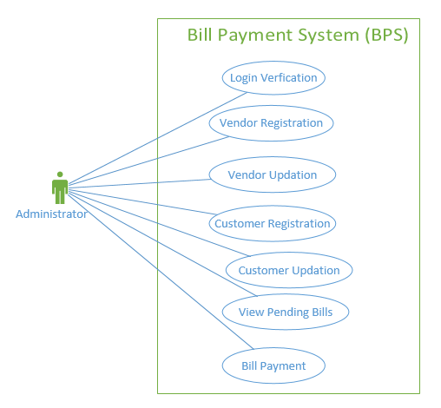

Exclusions
- The system will operate only on the modules discussed above and will not include any additional functionality.
- The Bill payment/Pending module will not include additional features such as funds revoke, etc. apart from viewing the pending bills and paying their corresponding bill amount.

System Perspective
The BPS is an independent software system developed to manage the activities like vendor registration, customer registration, Bill payment, etc. using the Java/Dotnet architecture.

System diagram
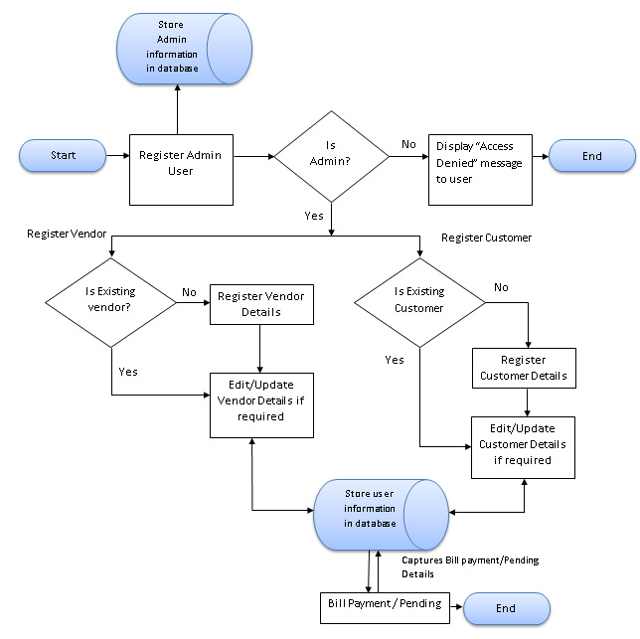

Architecture diagram

Physical Architecture:
A physical architecture is an arrangement of physical elements, (system elements and physical interfaces) that provides the designed solution for a product, service, or enterprise. It is intended to satisfy logical architecture elements and system requirements. Bill Payment System follows a three layered architecture namely presentation layer, business logic layer and data access layer.
- Presentation Tier is the tier in which the users interact with an application. Presentation Tier contents Shared UI code, Code Behind and Designers used to represent information to user.
- Business Tier is mainly working as the bridge between Data Tier and Presentation Tier. All the Data passes through the Business Tier before passing to the presentation Tier. Business Tier is the sum of Business Logic Layer, Data Access Layer and Value Object and other components used to add business logic.
- Data Tier is basically the server which stores all the application’s data. Data tier contents Database Tables, XML Files and other means of storing Application Data.
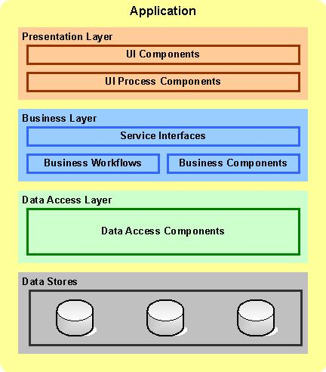

Logical Architecture:
The Logical Architecture defines the Processes (the activities and functions) that are required to provide the required User Services. Many different Processes must work together and share information to provide a User Service. The Processes can be implemented via software, hardware, or firmware. The Logical Architecture is independent of technologies and implementations.
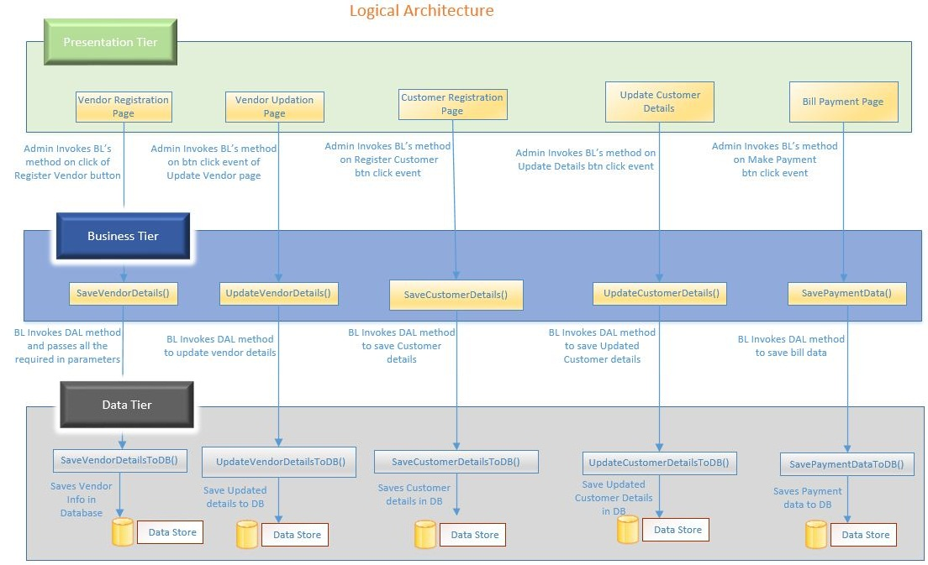

System Environment
The BPS application will be operated from the client server with parallel processor support. When a user connects to the Web Server, the Web Server will interact with the Database after processing the business logic to transfer data to and from a database.
- Java/J2EE or .NET Framework application deployment.
- My SQL/SQL server database for data storage

User Characteristics
The application should be user friendly; in such a way that the user would not need any software and hardware knowledge. The user may be new to the client products having never used them before.
The types of users likely to use the system are as follows,
- Client
- Delivery Assurance Group, Process Engineering group
- Developers, testers, other associates in the project

Impact of the System
This is a new product which is developed for internal users. Expected impact of the product is to automate existing manual processes in order to make them more efficient and cost effective.

Assumptions, Dependencies, Risks / Constraints
Assumptions:
- The processing admin must possess prior knowledge on BPS operations undertaken offline.
- The admin should have the details of the vendors and customers to be registered /updated into the system.
Dependencies:
- If there is any Bill payment procedure is required for other applications of the same client, this system should be able to accommodate such a reusability dependency.
Risks:
- If there is any failure in bill payment processes, the system should be able to handle such a financial risk.

Design Constraints
- The vendor modules and the customer modules should remain independent, without affecting the Bill payment operations.
- Application should have single login feature. Login functionality should be the welcome feature for the application.
- Only administrator can access the application.
- None of the application features can be accessed without login.

System Requirements

Functional Requirements

Home Module
Bill Payment System  Req-2.1.1 | Home Page
Functional Requirements | When the users enter the following link http://localhost/BillPaymentSystem in the browser, Home page appears which will have a short welcome message; a brief introduction to the purpose of the Bill Payment System, the user can choose appropriate options.  Under home page, we need below interface.
Home page Interface Requirements | - Admin

Admin

Register Vendor Page

Bill Payment System  Req-2.1.2.1 | Admin - Register Vendor
Functional Requirements | - Administrator should log in to the system.  - Administrator should able to “Register Vendor”.  - YOS (Years of Survival) should be calculated based on the YOE (Year of Establishment).  - Certificate details should be populated based on the YOS and Employees count.  - Certificate validity should be calculated based on the certificate issued date.  - Vendor type should be populated from the system.
User Interface Requirements | - Name – Name of the vendor.  - Company Reg. No - Represent the company Registration number.  - Vendor Type – Represents the company type  - Address – Represent the address.  - Country –represents the country.  - State –represents the state.  - Email Address – Represents the email address.  - Contact number – Represent the vendor contact number.  - Web site – Represent the vendor application name.  - Certificate Issued Date - Represent the issued date.  - Certificate Validity date - Represent the certificate validity date.  - Employees Count- Represents the number of employees.  - Customer Count – Represents the number of customer, the vendor has.  - Year of Establishment- represents the year of establishment.  There should be 2 buttons i.e. Register, reset
Trigger | Administrator triggers the functionality once he/she receives the details of the vendor.
Pre-Conditions / Assumptions | The admin should have the details of the vendor to be registered into the system.
Post Conditions | Vendor should get registered into the system.
Success End Condition | On success a message should be displayed “Vendor Registered successfully”
Failed End Condition | The system should throw an error message if one of the validations is wrong. The validation and business rules are mentioned in the business rules section.
Steps & Actions | - Based on the company registration number, vendor name will be populated from the system.  - Based on the country, state has to be populated automatically.  - System needs to store the vendor details into the system.  - Identity the Vendor name based on the company Registration number as follows:  - Identify the country id based on the vendor country and state details as follows:  - Identify the Vendor type and the corresponding amount as follows: This should be changeable in the system at any point of time.  - Certificate can be issued based on the YOS. YOS can be calculated as follows.  This should be changeable in the system at any point of time.  YOS= current year – YOE
  Company Registration number | Vendor Name | Vendor type
  12345 | TNEB | Electricity
  23456 | Airtel | Telephone
  23457 | Aircel | Telephone
  34567 | LIC | Insurance
  34568 | Bajaj alliance | Insurance
  45678 | Income Tax | Tax
  Country Id | Country | State
  C01 | India | TamilNadu
  C02 | India | Kerala
  C03 | India | Karnataka
  C04 | India | Andhra Pradesh
  C05 | UK | Scotland
  C06 | USA | New Jersey
  C07 | Italy | Rome
  Vendor type | Amount
  Electricity | 1000
  Telephone | 2000
  Insurance | 1200
  Tax | 700
  YOS | Employees Count | Certificate
  1 -5 | >=30 and <50 | A+
  5-10 | >=50 and <75 | B+
  10-15 | >=75 and <100 | C+
  15-25 | >=100 and <200 | D+
  25-50 | >=200 and <500 | E+
  >50 | >500 | F+
Business Rules & Validations | - All fields are mandatory.  - The vendor name should contain only alphabets and space.  - The vendor id should be automatically generated by the system and format should be ‘XXXXX’. XXXXX- should be a numeric of 5 digits.  - Contact number should be 10 digits.  - The Vendor name should starts with uppercase letter.  - Email Address should be in this format. Ex. abc@xyz.com  - Web Site should be in this format “www.XXX.com”. (XXX- vendor application name)  - Based on the country, state has to be populated automatically.  - Based on the YOE, YOS can be calculated and based on it certificate should be generated.  - YOS should contain only positive values.  - Certificate issue date should be system date.  - Certificate validity date should be greater than system date.  - YOE should be numeric of 4 digits and should not be less than 1900. And should not be greater than current year.  - Certificate Validity should be Certificate issue date + 15 years.  - At the time of registration, the following task needs to be done:  - Certificate details based on the YOS(based on the YOE and employees count)  - Certificate validity date will be calculated based on the issued date.(issued date +15 years)  - Retrieve Country id for the given country and state.  - Retrieve the vendor name and vendor type based on the company Registration number.  - Update the above details automatically into the system along with the vendor details.

Vendor Updation Page

Bill Payment System  Req-2.1.2.2 | Admin – Update Vendor
Functional Requirements | - Administrator logs in to the system.  - Administrator should able to Update Vendor option.  - Administrator should provide the vendor id that needed to be updated.  - System should display all the necessary fields in the screen.  - All fields should be retrieved from system.
User Interface Requirements | Vendor Selection Screen:  Vendor ID – represents vendor ID to choose the vendor  Vendor Updation Screen:  - Vendor Id – Represents the selected vendor.  - Company Reg. No. - Represent the company Registration number.  - Vendor Name – Represents the company name  - Vendor Type – Represents the company type  - Certificate – Represent the certificate.  - Certificate Issued Date - Represent the issued date.  - Certificate Validity date - Represent the certificate validity date.  - Year of Establishment- represents the year of establishment.  - Country – represents the country.  - State – represents the state.  - Address – Represent the address.  - Contact Number – Represent the vendor contact number.  - Email Address – Represents the email address.  - Web site – Represent the vendor application.  - Employees Count- Represents the number of employees.  - Customer Count – Represents the number of customers
Trigger | Administrator triggers the functionality once he/she receives the details of the vendor.
Pre-Conditions / Assumptions | The admin should have the details of the vendor to be updated into the system.
Post Conditions | The admin should update the vendor details to the system.
Success End Condition | On success a message Report should be generated “Vendor Updated successfully”
Failed End Condition | The system should throw an error message if one of the validations is wrong. The validation and business rules are mentioned in the business rules section.
Steps & Actions | - System needs to update the vendor details into the system.  - At the time of clicking the update button, the following task needs to be done:  - Certificate details based on the YOS (based on the YOE and employees count)  - Certificate validity date will be calculated based on the issued date (issued date +15 years).  - Certificate can be issued based on the YOS. YOS can be calculated as follows.  This should be changeable in the system at any point of time.  YOS= current year – YOE  All the edited fields will be updated into the system
  YOS | Employees Count | Certificate
  1 -5 | >=30 and <50 | A+
  5-10 | >=50 and <75 | B+
  10-15 | >=75 and <100 | C+
  15-25 | >=100 and <200 | D+
  25-50 | >=200 and <500 | E+
  >50 | >500 | F+
Business Rules & Validations | - All fields are mandatory.  - Email id should be in this format. Ex. abc@xyz.com  - Web Site should be in this format “www.XXX.com”. (XXX- vendor application name)  - Contact number should be numeric and contains only 10 digits.  - Based on the YOE (Year of Establishment) and employees count, YOS (Years of Survival) can be calculated and based on it certificate should be generated.  - YOS should contain only positive values.  - Certificate issue date should be system date.  - Certificate Validity should be Certificate issue date + 15 years.  - Password and confirm password should be same.

Register Customer Page

Bill Payment System  Req-2.1.2.3 | Admin - Register Vendor
Functional Requirements | - Administrator logs in to the system.  - Administrator should be able to “Register customer” option.
User Interface Requirements | This should capture the following fields  - Customer Name – Represents name of the customer.  - Address – Represents the address of the customer.  - Contact Number – Represent the phone number of the customer.  - Country – Represent the country of the customer.  - State – Represents the state of the customer.  - Mail Id - Represents the mail id of the customer.  - Identification document – Represents the list of proof details. (Voterid, driving license, passport, pancard).  - Document Detail Number – Represents proof number.  - Registration date - Represents registration date of the customer.  - Type of vendor – represents vendor type.  - Electricity – Represents type of vendor  - Telephone – Represents type of vendor  - Insurance – Represents type of vendor  - Tax – Represents type of vendor  - Card No – Represents Card Number of customer  - Balance – Represents Balance of customer.
Trigger | Administrator triggers the functionality once he/she receives the details of the customer.
Pre-Conditions / Assumptions: | The admin should have the details of the customer to be registered into the system.
Post Conditions | The customer details should be registered in the data base.
Success End Condition | On success a message should be displayed “Customer Registered successfully”
Failed End Condition | The system should throw an error message if one of the validations is wrong. The validation and business rules are mentioned in the business rules section.
Steps & Actions | - System should display all the necessary fields in the screen.  - Customer ID should be generated automatically during the time of registration.  - Verify the Document number of the customer based on the standard as follows:  - Identify the country ID based on the customer country and state details as  - System needs to store the customer details into the system.
  Identification document | Prefix Format
  Voter Id | GMV
  Pass port | PASS
  Driving License | DL
  PAN card | PAN
  Country Id | Country | State
  C01 | India | TamilNadu
  C02 | India | Kerala
  C03 | India | Karnataka
  C04 | India | Andhra Pradesh
  C05 | UK | Scotland
  C06 | USA | New Jersey
  C07 | Italy | Rome
Business Rules & Validations | - All fields are mandatory.  - The name should contain only alphabets and space.  - The Customer number should be automatically generated by the system and format should be ‘XXX’.XXX should be a numeric of 3 digits.  - Customer name should not be same as username  - Email Address should be in this format. Ex. abc@xyz.com  - Card number should be a numeric of 16 digits.  - At the time of registration, the following task needs to be done:  - Retrieve the country id for the given country and state.  - Document Detail Number should be prefix format based on the above info.  Update the above details automatically into the database along with the customer details.

Customer Updation Page

Bill Payment System  Req-2.1.2.4 | Admin - Update Details of Customer
Functional Requirements | - Administrator logs in to the system.  - Administrator should able to update customer option.
User Interface Requirements | - Customer Id – Represent the ID of the customer.  - Customer Name – Represents name of the customer.  - Country – Represent the country of the customer.  - State – Represents the state of the customer.  - Address – Represents the address of the customer.  - Contact Number – Represent the phone number of the customer.  - Mail Id - Represents the mail id of the customer.  - Type of vendor – Represents vendor types  - Electricity – Represents type of vendor  - Telephone – Represents type of vendor  - Insurance – Represents type of vendor  - Tax – Represents type of vendor  - Card No – Represents Card Number of customer  - Balance – Represents Balance of customer
Trigger | Administrator triggers the functionality once he/she receives the details of the Customer.
Pre-Conditions / Assumptions | The admin should have the details of the Customer to be registered into the system.
Post Conditions | The admin should update the Customer details to the system.
Success End Condition | On success a message Report should be generated “Customer Updated successfully”
Failed End Condition | The system should throw an error message if one of the validations is wrong. The validation and business rules are mentioned in the business rules section.
Steps & Actions | - System should display all the necessary fields in the screen.  - All fields should be retrieved from database.  - System needs to update the edited Customer details into the system.
Business Rules & Validations | - All fields are mandatory.  - Contact no should be numeric and contains only 10 digits.  - Email Address should be in this format. Ex. abc@xyz.com  - Card number should be a numeric of 16 digits.

Bill payment Page

Bill Payment System  Req-2.1.2.5 | Admin - Bill Payment
Functional Requirements | - Administrator logs in to the system.  - Administrator should able to Pay Bill.
User Interface Requirements | - Customer ID – Represents ID of the customer.  - Vendor Type – Represent different vendor types.  - Vendor Name – Represent the vendor names.  - Pending Amount – Represent the Vendor’s amount.  - Payment date – Represent the payment date. Default to system date.  - Amount to Pay – Represent amount to pay.  - Card Type – Choice of card type either Credit Card or Debit Card.  - Card Number – Represent the card number.  - Confirm Card Number – Represent the card number.  - Card Validity – Label  - MM – Credit card validity date. MM represents month.  - YYYY – Credit card validity date. YYYY represents year.  - CVV – Represents the CVV number.
Trigger | Administrator triggers the functionality of pending and paying bills.
Pre-Conditions / Assumptions | The vendor and customer should register their details into the system.
Post Conditions | The customer and vendor will view the pending bills from the table.  The customer will pay the bills along with vendor type based on the given criteria.
Success End Condition | Display the success message on the screen as “Bills are paid successfully”.
Failed End Condition | The system should throw an error message if one of the validations is wrong. The validation and business rules are mentioned in the business rules section.
Steps & Actions | - Enter the customer ID and vendor type.  - After entering the vendor type, system should fetch the appropriate vendor names.  - Identity the Vendor name based on the company Registration number as follows:  - After selecting the vendor type and tab. System should display the pending amount.  - Display the Vendor Amount in the Pending Amount field.  - Identify the vendor’s amount based on the following table:
  Company Registration number | Vendor Name | Vendor type
  12345 | TNEB | Electricity
  23456 | Airtel | Telephone
  23457 | Aircel | Telephone
  34567 | LIC | Insurance
  34568 | Bajaj alliance | Insurance
  45678 | Income Tax | Tax
  Vendor type | Amount
  Electricity | 1000
  Telephone | 2000
  Insurance | 1200
  Tax | 700
Business Rules & Validations | - All fields are mandatory.  - Amount should have two decimal point values (i.e 1233.45).  - Amount should not be negative.  - Pending Amount >= Amount to pay.  - On selecting Vendor type, corresponding vendor names should be displayed.  - On vendor type, pending amount should be displayed.  - Credit card number and confirm credit card number should be same.  - Card Validity should be in MM and YYYY format. Drop down should display “01, 02 …. 12” for Months. Drop down should display “2012, 2013….. 2015”.  - CVV number should be 3 digits.

Nonfunctional Requirements

UI Requirements: Inn
- The front end should be user-friendly and pleasant
- Any error message or exception displayed to the user should be user-readable (and not technical)
- All entered values should be validated
- The UI screens are designed with any theme color along with the logo of the company.
- Exceptions should not be shown on console.
- No debug message should come on console.
- All the errors and exceptions should be logged to log file.
- Log file path should be configurable.
- Database connections should be configurable.
- It should not be hard coded.
- Requirements involving UI features should be taken care in console accordingly

Performance Requirements: Pnn
- All front-end pages should be served up in less than 5 seconds post click when up to 1000 users are on the application concurrently.
- Since it’s a financial operations application, transactions should be safe and fast.

Installation, Deployment & Operational Requirements: Onn
- Application Java and J2EE deployment with My SQL database or SQL Server database for persistence
Or
Application .NET Framework deployment with SQL Server database for persistence
- This system must be up 24X7

Maintainability & Portability Requirements: MPnn
- If the allocated memory space for the existing application needs to be increased then it should be possible without any impact to performance

Security Requirements Snn:
- No unauthorized users should be able to log on to the system
- User Id/Login Id should have combination of letter and numeric values, none of the special characters are allowed (#,@,$,%,&).
- Validate the user id/login id and password, accordingly to the user it will redirect to the appropriate page.

Requirements / Use Case Summary Table

Business Requirement ID | Software Requirements ID | Short Description | Requirement Provider (Originator) | Priority | Complexity | Requirement type | Remarks
BR001 | SR001 | Vendor Registration module | Client | High | Medium | UI screen & backend processing | -
BR002 | SR002 | Vendor Updation module | Client | Medium | Medium | UI screen & backend processing | -
BR003 | SR003 | Customer Registration module | Client | High | Medium | UI screen & backend processing | -
BR004 | SR004 | Customer Updation module | Client | Medium | Medium | UI screen & backend processing | -
BR005 | SR005 | Bill payment/Pending module | Client | High | High | UI screen & backend processing | -

Make /Buy analysis

Reusable components
The BPS can be made reusable as such to handle various other bill payment procedures as it forms the base for working on activities that involve billing procedures online.

Annexure
NA

Change Log
Please note that this table needs to be maintained even if a Configuration Management tool is used.
Version Number | Changes made
V1.0 | First version developed by Sharika V on Nov 14 2014.
V1.1 | <If the change details are not explicitly documented in the table below, reference should be provided here>
V1.1 | Page no | Changed by | Effective date | Changes effected
V1.2 | <If the change details are not explicitly documented in the table below, reference should be provided here>
V1.2 | Page no | Changed by | Effective date | Changes effected

